THIS SHEET IS FOR:- MANUFACTURE OR QUOTATION ONLY
FOR ANY QUERIES REGARDING THE INFORMATION ON THIS SHEET, PLEASE CONTACT:- 01204 871001
CLIENT |  |  |  |  |  |  | DELIVERY ADDRESS
QUOTATION NUMBER  (IF APPLICABLE) |  |  |  |  |  |  | DELIVERY REQUIRED
ORDER NUMBER DATE |  |  |  |  |  |  | SIGNATURE
 |  |  |  |  |  |  | PRINT NAME
TOTAL NUMBER OF DOORS REQUIRED |  |  |  |  |  |  |  | 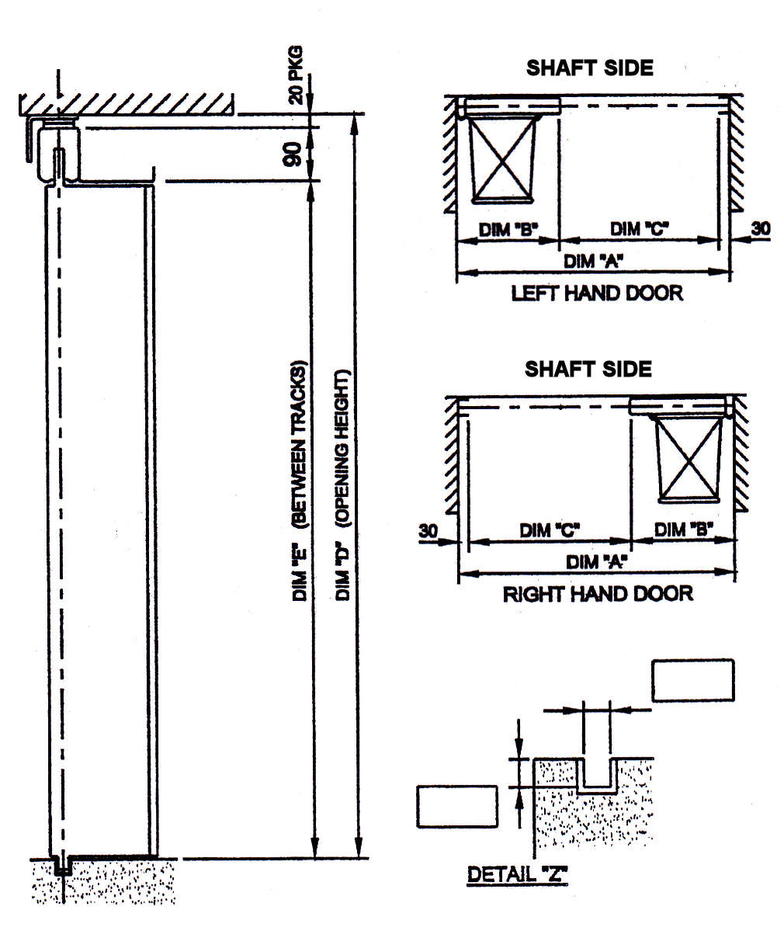
NUMBER OF RIGHT HAND DOORS
NUMBER OF LEFT HAND DOORS
LEAF SIZE REQUIRED (152 OR 229)
DOOR TYPE |  |  |  |  | LH |  | RH
DIMENSION ”A” (OVERALL WIDTH)
DIMENSION ”C” (CLEAR WIDTH)
DIMENSION ”D” (OPENING HEIGHT)
DIMENSION ”E” (BETWEEN TRACKS)
90mm TOP TRACK REQUIRED |  |  |  |  | YES |  | NO
IF NO, SUPPLY DETAILS OF THE EXISTING TRACK
BOTTOM TRACK REQUIRED |  |  |  |  | YES |  | NO
IF NO, SHOW DIMENSIONS OF EXISTING IN DETAIL “Z”
RECESSED HANDLE (SHAFT SIDE) |  |  |  |  | YES |  | NO
VISION PANEL (229mm X 89mm) |  |  |  |  | YES |  | NO
MATHEWS CATCH |  |  |  |  | YES |  | NO
PREPARATION FOR LOCK |  |  |  |  | YES |  | NO
IF YES, SUPPLY DETAILS
STANDARD GALVANISED FINISH |  |  |  |  | YES |  | NO
IF NO, SUPPLY DETAILS
Bolton Gate Company Ltd.
Waterloo Street
Bolton
BL1 2SP

Tel: 01204 871001
Website: -
www.boltongate.co.uk
E-Mail:-
Sales@boltongate.co.uk

SPECIAL REQUIREMENTS

