THIS SHEET IS FOR:- MANUFACTURE OR QUOTATION ONLY
FOR ANY QUERIES REGARDING THE INFORMATION ON THIS SHEET, PLEASE CONTACT:- 01204 871001
CLIENT |  |  |  |  |  |  | DELIVERY ADDRESS
QUOTATION NUMBER  (IF APPLICABLE) |  |  |  |  |  |  | DELIVERY REQUIRED
ORDER NUMBER DATE |  |  |  |  |  |  | SIGNATURE
 |  |  |  |  |  |  | PRINT NAME
TOTAL NUMBER OF GATES REQUIRED |  |  |  |  |  |  |  | 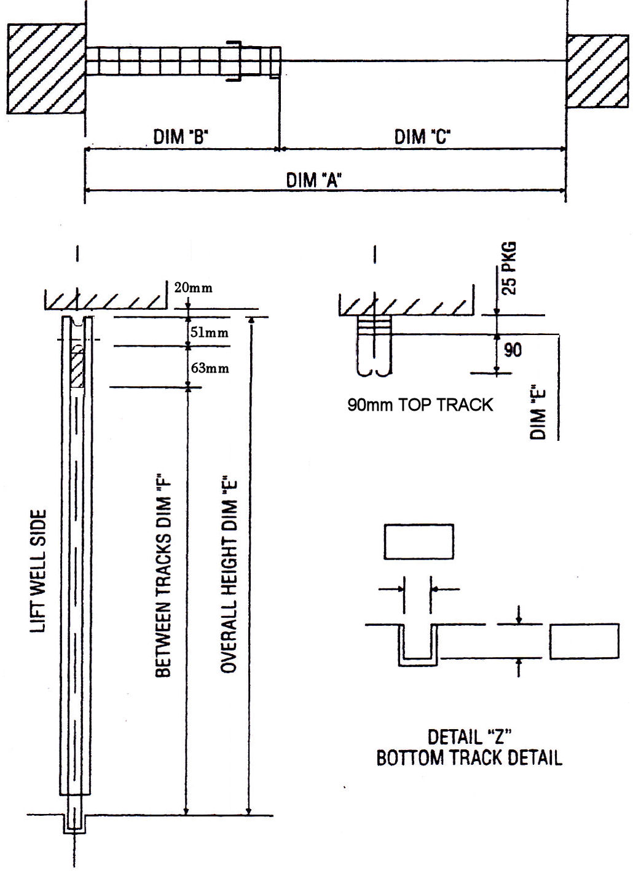
NUMBER OF RIGHT HAND GATES
NUMBER OF LEFT HAND GATES
DIMENSION “A” (OVERALL WIDTH)
DIMENSION “C” (CLEAR WIDTH)
DIMENSION “E” (OVERALL HEIGHT)
DIMENSION “F” (BETWEEN TRACKS)
STANDARD 90mm BOX TYPE  TOP TRACK REQUIRED |  |  |  |  | YES |  | NO
63 x 16 ONE ROUND EDGE TYPE  TOP TRACK REQUIRED |  |  |  |  | YES |  | NO
BOTTOM TRACK REQUIRED |  |  |  |  | YES |  | NO
IF NO, SHOW DIMENSIONS OF EXISTING IN DETAIL “Z”
HANDLE No. 1 (BOW) |  |  |  |  | YES |  | NO
HANDLE No. 3 (FINGER) |  |  |  |  | YES |  | NO
REINFORCED FRONT |  |  |  |  | YES |  | NO
STANDARD GALVANISED FINISH |  |  |  |  | YES |  | NO
IF NO, SUPPLY DETAILS
Bolton Gate Company Ltd.
Waterloo Street
Bolton
BL1 2SP

Tel: 01204 871001
Website: -
www.boltongate.co.uk
E-Mail:-
sales@boltongate.co.uk

SPECIAL REQUIREMENTS

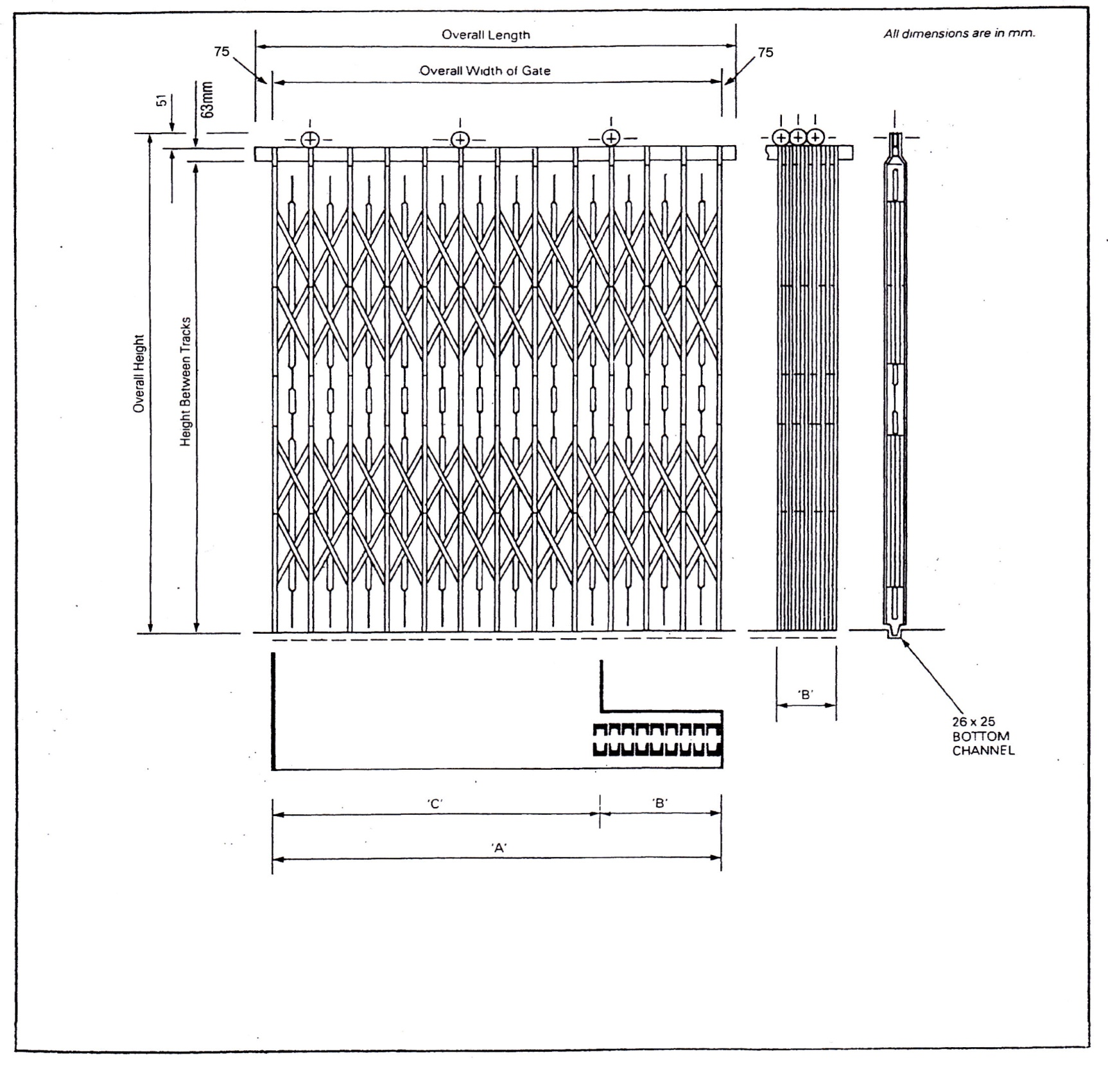
16mm pickets | NUMBER OF PICKETS
 | 5 | 6 | 7 | 8 | 9 | 10 | 11 | 12 | 13 | 14 | 15 | 16 | 17 | 18 | 19 | 20 | 21
Max Width | 600 | 746 | 892 | 1038 | 1184 | 1330 | 1476 | 1622 | 1768 | 1915 | 2061 | 2207 | 2353 | 2499 | 2645 | 2662 | 2679
Bunch | 87 | 105 | 122 | 140 | 157 | 175 | 192 | 210 | 227 | 244 | 262 | 279 | 296 | 313 | 330 | 347 | 364

